**1. Create a field on Account named "Number of Contacts". Populate this field with the number of contacts related to an account.**

**Apex Class::**

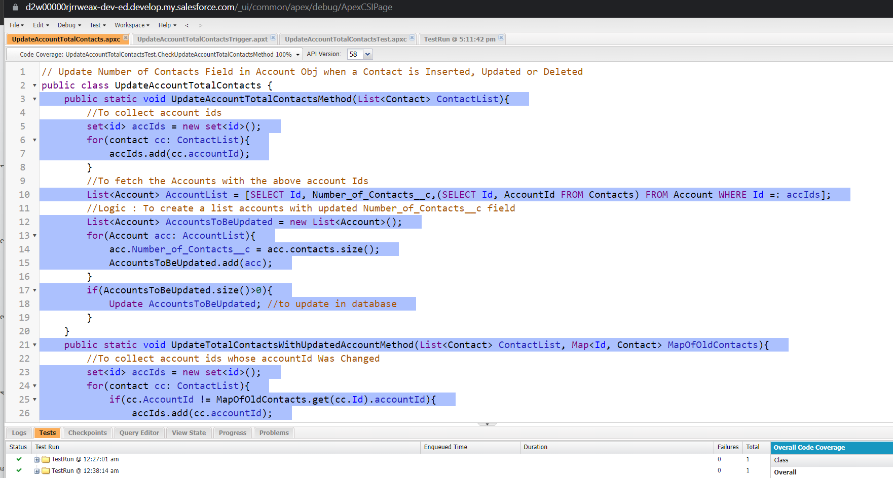

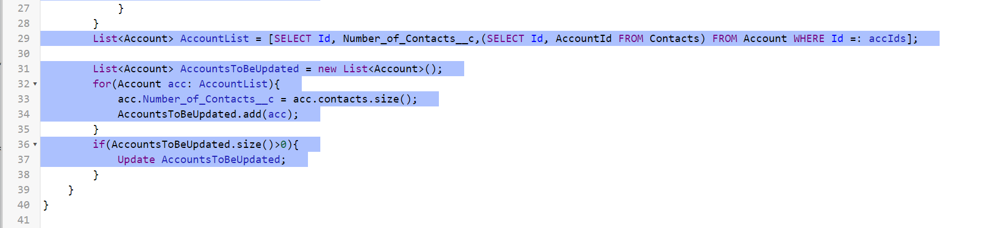

**Trigger::**

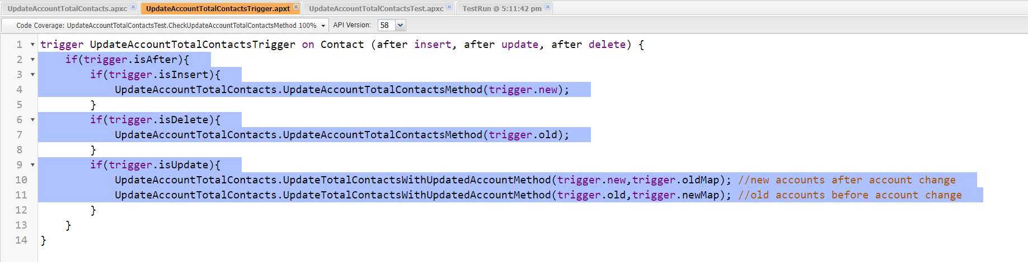

**Test Class::**

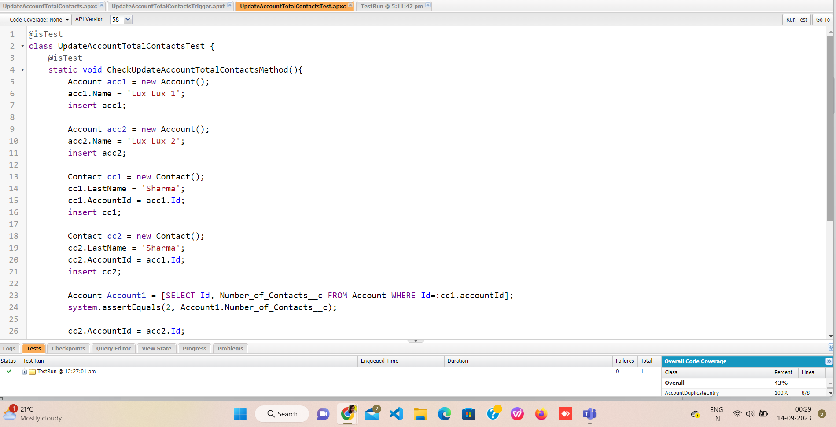

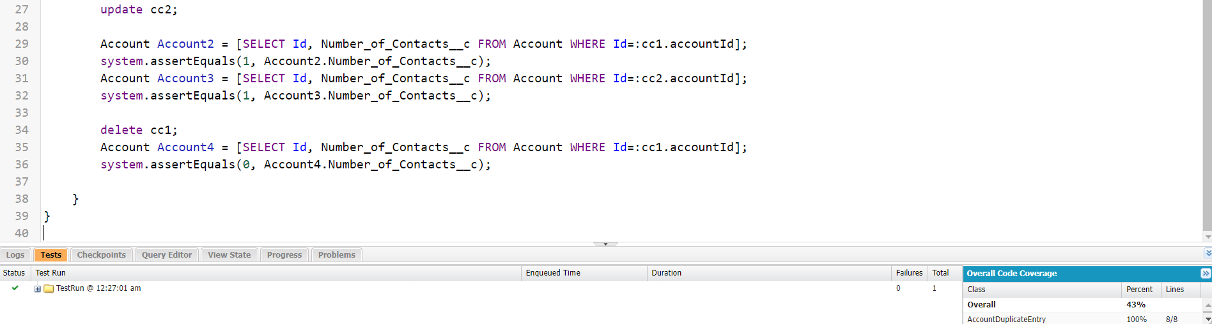

**2. Build a basic lightning component that can query a list of 10 most recently created accounts and display it using a lightning app.**

* Created Apex Method

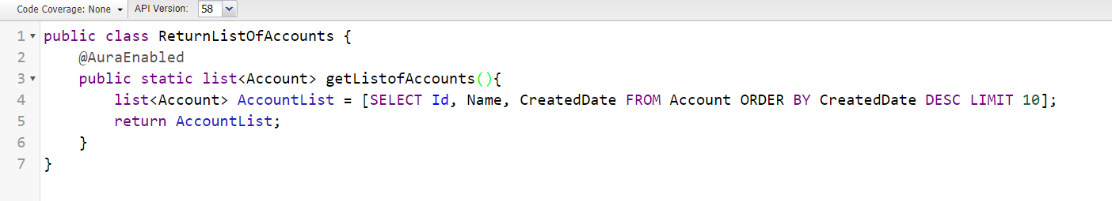

* Created LWC (html file, js file and meta.xml file)

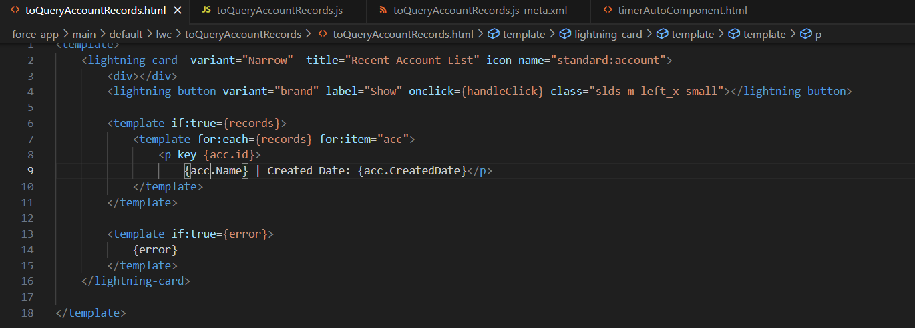

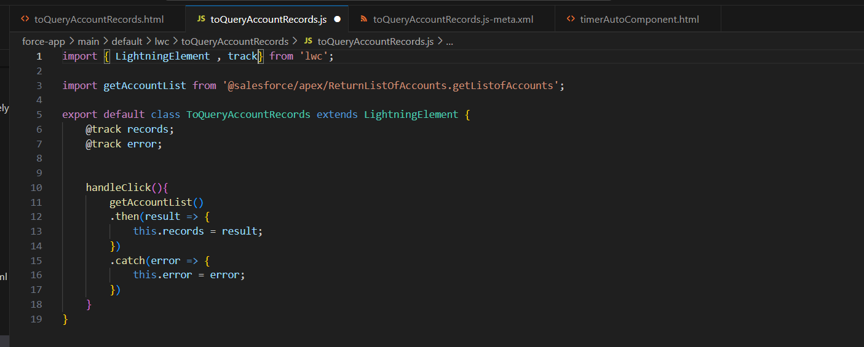

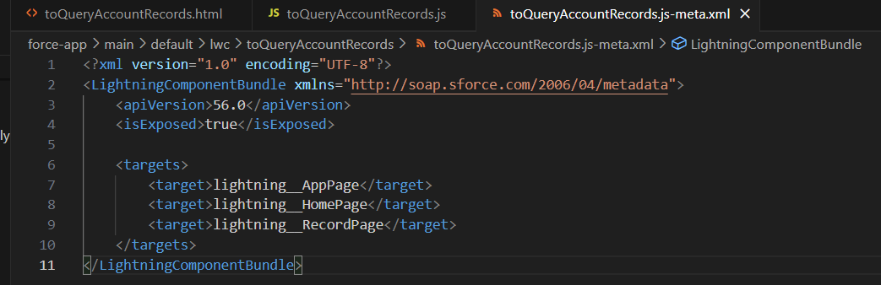

* Added Component in Lightning Page

(after the lightning page loaded)

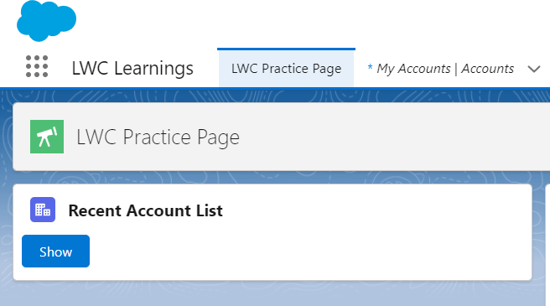

(After clicking on “Show” button)

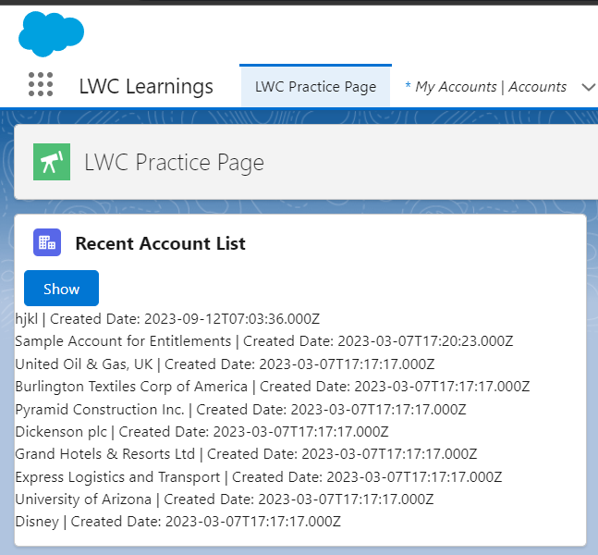

**3. Make a basic http callout and print the result using system.debug**

<https://postman-echo.com/get?foo1=bar1&foo2=bar2>

* **Register the endpoint with “Remote Site Settings”**

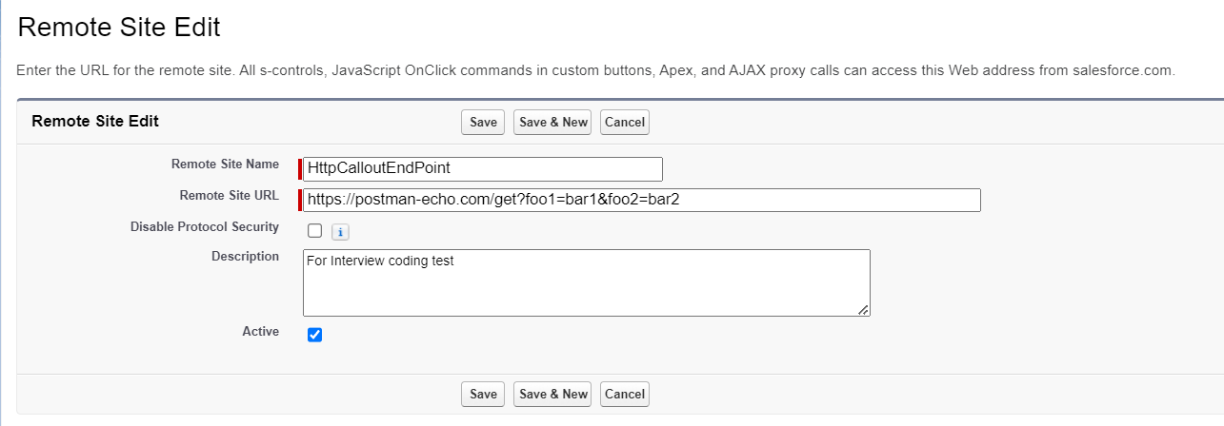

* **Created BasicHttpCalloutClass class to make the HTTP Callout and print the result**

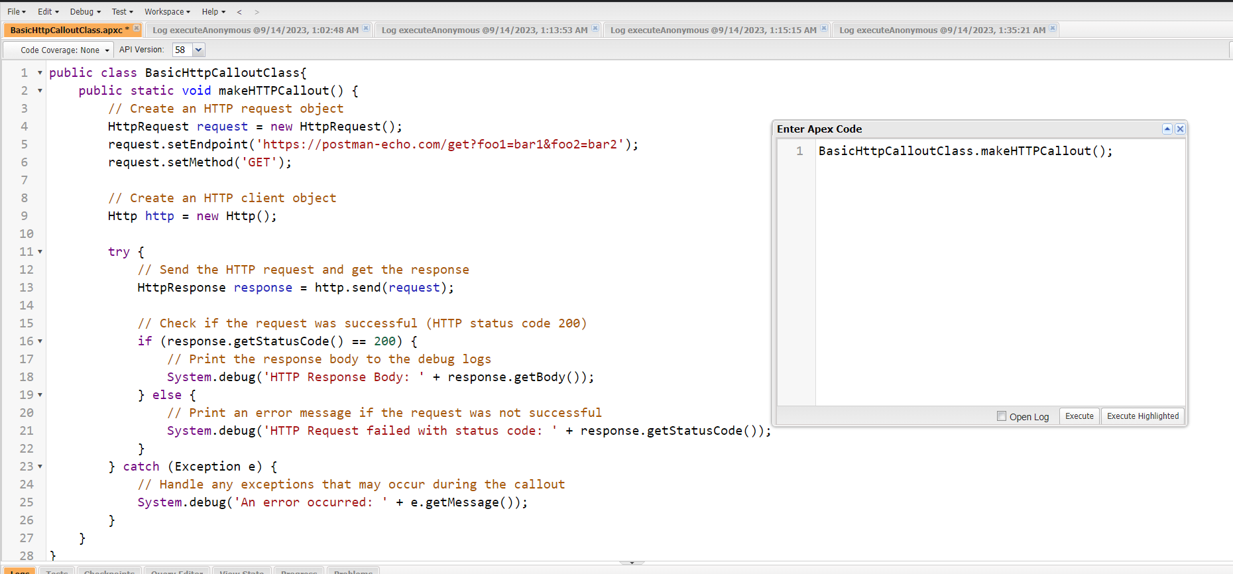

**Result::**

